**EXL EQ 2018**  
**Outliers DTU**  
**_______**  
**Arnav Saxena Mudit Mangal arnavsaxenadtu@gmail.com mmudit96@gmail.com**

1. **Layout Changes based on Density Zones and Floor Analysis**

We have already divided all the floors in the mall into various density zones (Slide 1) and suggested shifting of stores so as to come up with a better layout to make customers purchase more. Here we talk about achieving the same for real.

We first did Floor wise Category analysis to find out which categories are to be clubbed and placed on which floor. This was done on the basis of performance of a category on every floor (Plot B). With this we were able to find what all stores were to be swapped from which floor to which.  
  
After this, we used the density zones generated in Slide 1 to decide the location on every floor of the stores which are to be shifted on that floor.  
  
  
  
  
**Floor Analysis**

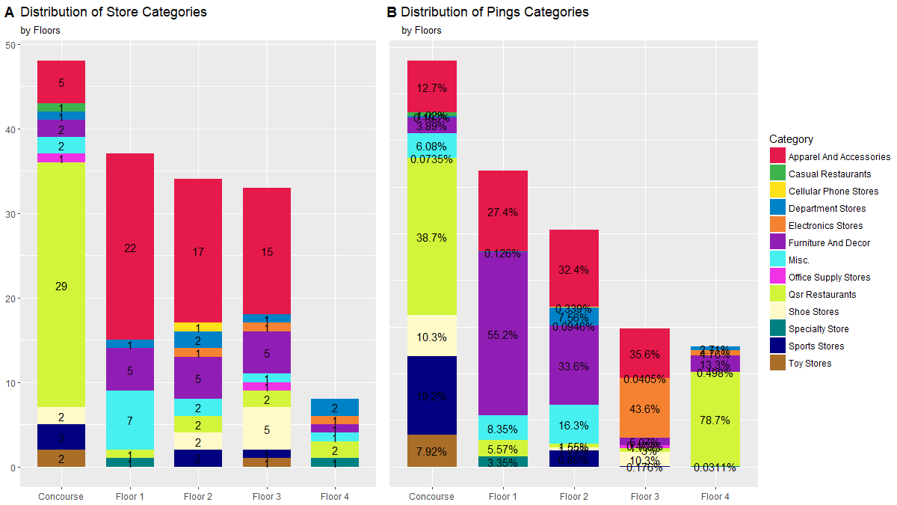  
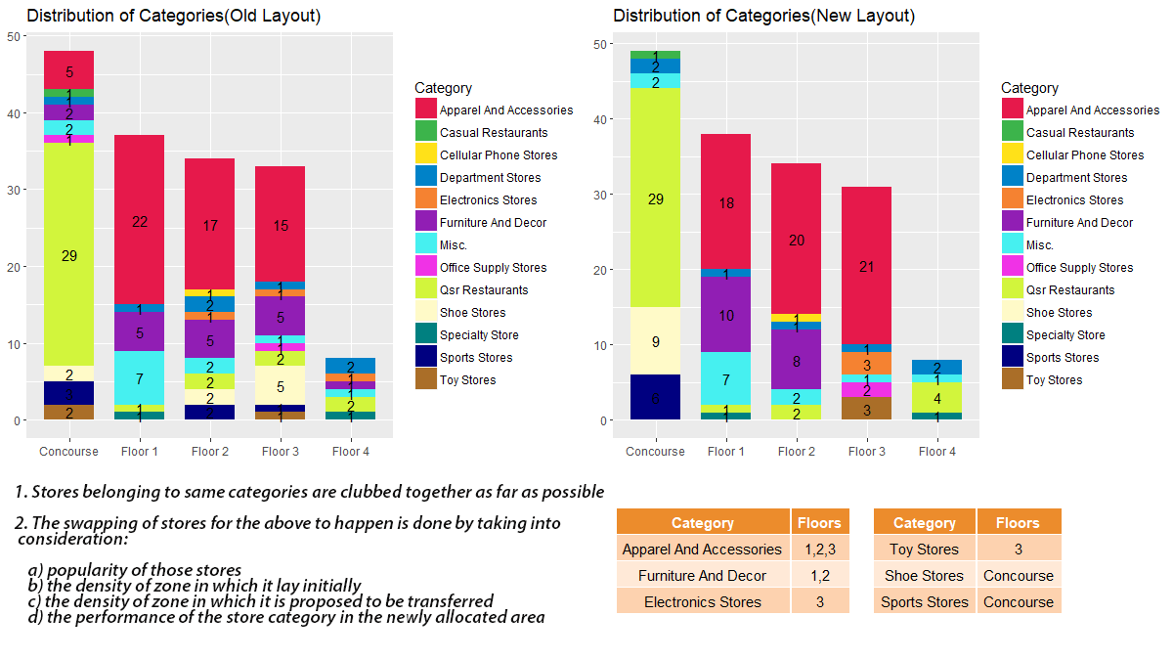

**Old Layout Floor 1 and Floor 2**

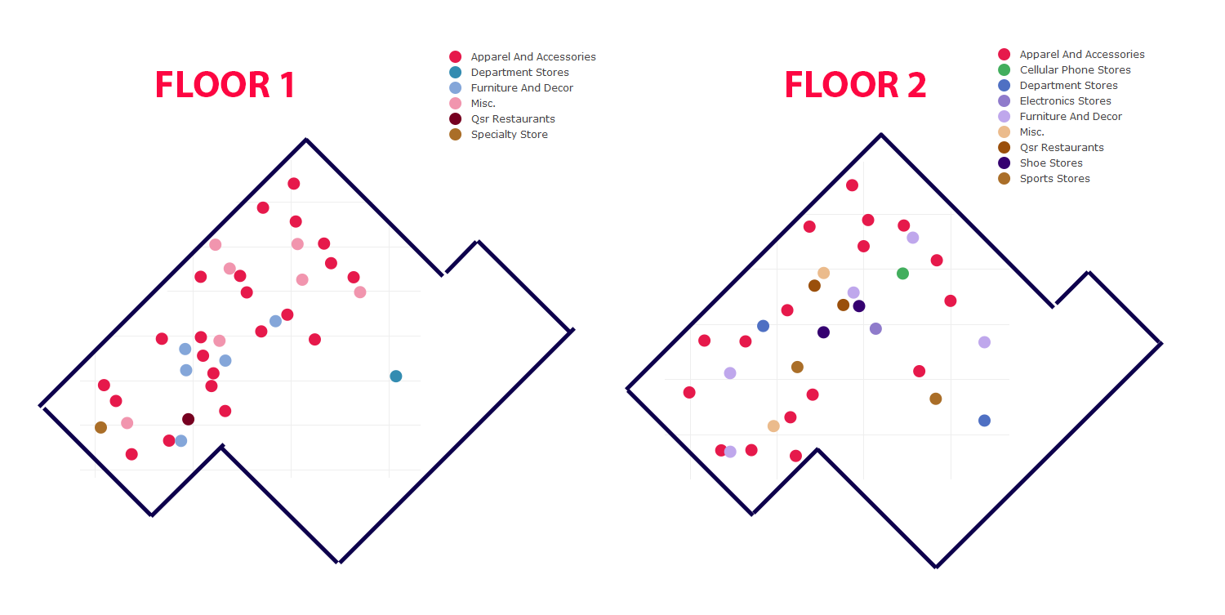

**New Layout Proposed: Floor 1 and Floor 2**

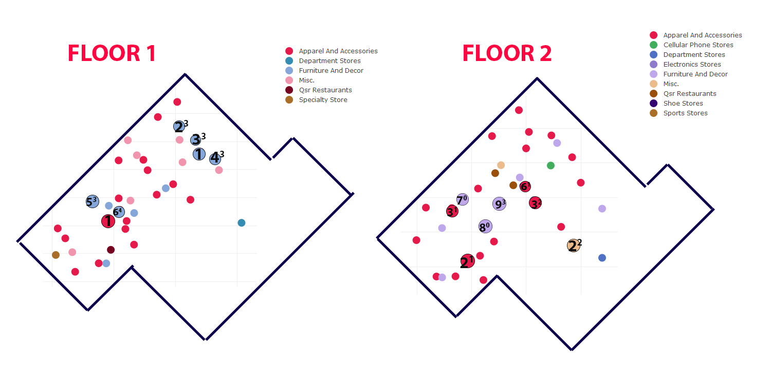

**2. Shopper Clustering Model**  
We first allocated each shopper his top visited Fine Category.  
Then the shoppers were segmented into various clusters on the basis of their demographics and the Top Visited Fine Category using **Partitioning Around Medoids (PAM) clustering.**   
  
*(The reason for choosing PAM was that it is suitable for clustering data when it has both numeric (here, Age and Number of Children) and categorical variables (here, Gender, Marital Status, Home Ownership, Fine Category)*  
  
**Perform PAM**:   
We used the pam function from the Cluster package in R.  
 *pam(x, k, diss=TRUE ,metric)*  
As per the syntax of PAM we basically need two inputs to get appropriate clusters  
 (i) x, dissimilarity matrix  
 (ii) k, number of clusters  
We proceed as follows.   
   
**Step 1: Generating the dissimilarity matrix (GOWER_MAT)**  
We used Gower distance to compute the dissimilarity matrix between each shopper as shown.  
  
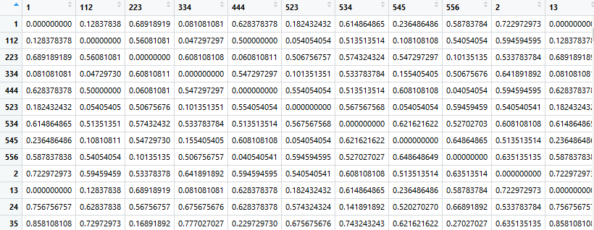  
  
  
**Step 2: Finding Optimum Number of Clusters (k)**   
We used Silhouette Width Technique to find the optimum number of clusters (k) to be extracted from the given data.   
  
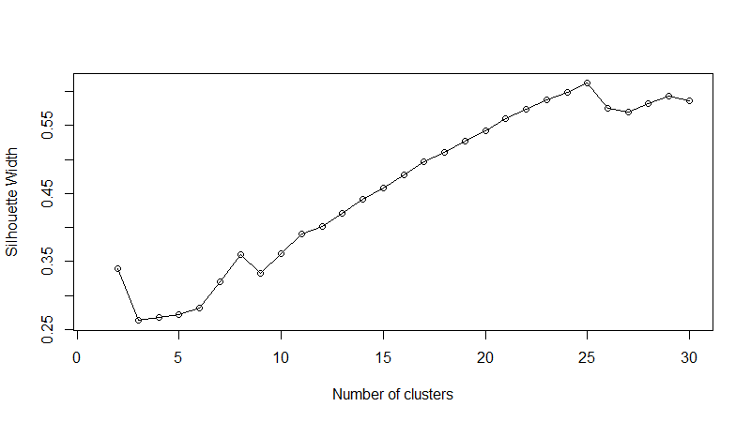  
  
As seen from the plot above, we found the optimum k (where the plot peaks) to be 25

**Step 3: PAM clustering**  
The following inputs were given to the pam function   
x = Gower_Mat (Step 1)  
k = 25 (Step 2)  
  
The following 25 clusters were obtained as output  
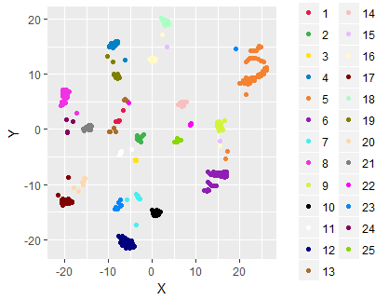

Just to give an idea about what kind of clusters were obtained, here are properties of some of the clusters:  
  
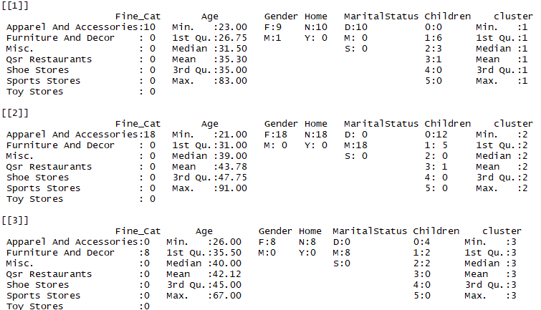

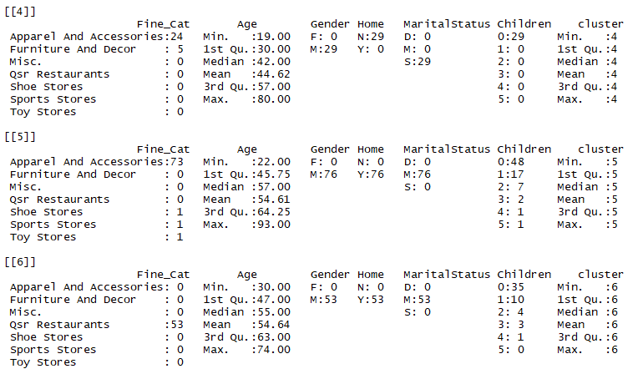

**Using the obtained clusters for personalized targeting**  
  
Given a new customer, X and his demographic information (Age, Gender, Home Ownership, Marital Status, Number of Children), we can assign the Fine_Category for which they can be targeted (and hence the appropriate stores).  
  
The following method is proposed to achieve the same.  
  
We have the representative medoids for all the 25 clusters formed. We can find a similarity score between the new customer and these medoids and set a threshold score above which a cluster can be assigned to the new shopper.   
The similarity score we have used is **1- gower_distance.**  
  
**EXAMPLE**  
Consider a new customer X with the following demographics:  
Age = 55, Gender = Male, Owns Home = Yes, Marital Status = Married, Number of Children = 2   
  
Using our similarity measure (1-gower_distance) we get the following similarity score against all the clusters for our new customer  
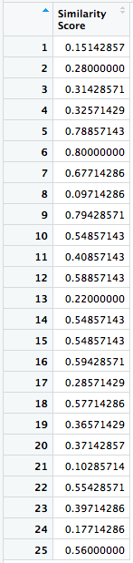   
  
Experimentally the threshold for assigning the clusters can be worked out to be **0.75**  
  
Thus we get the following clusters and categories assigned to the new shopper X.  
  
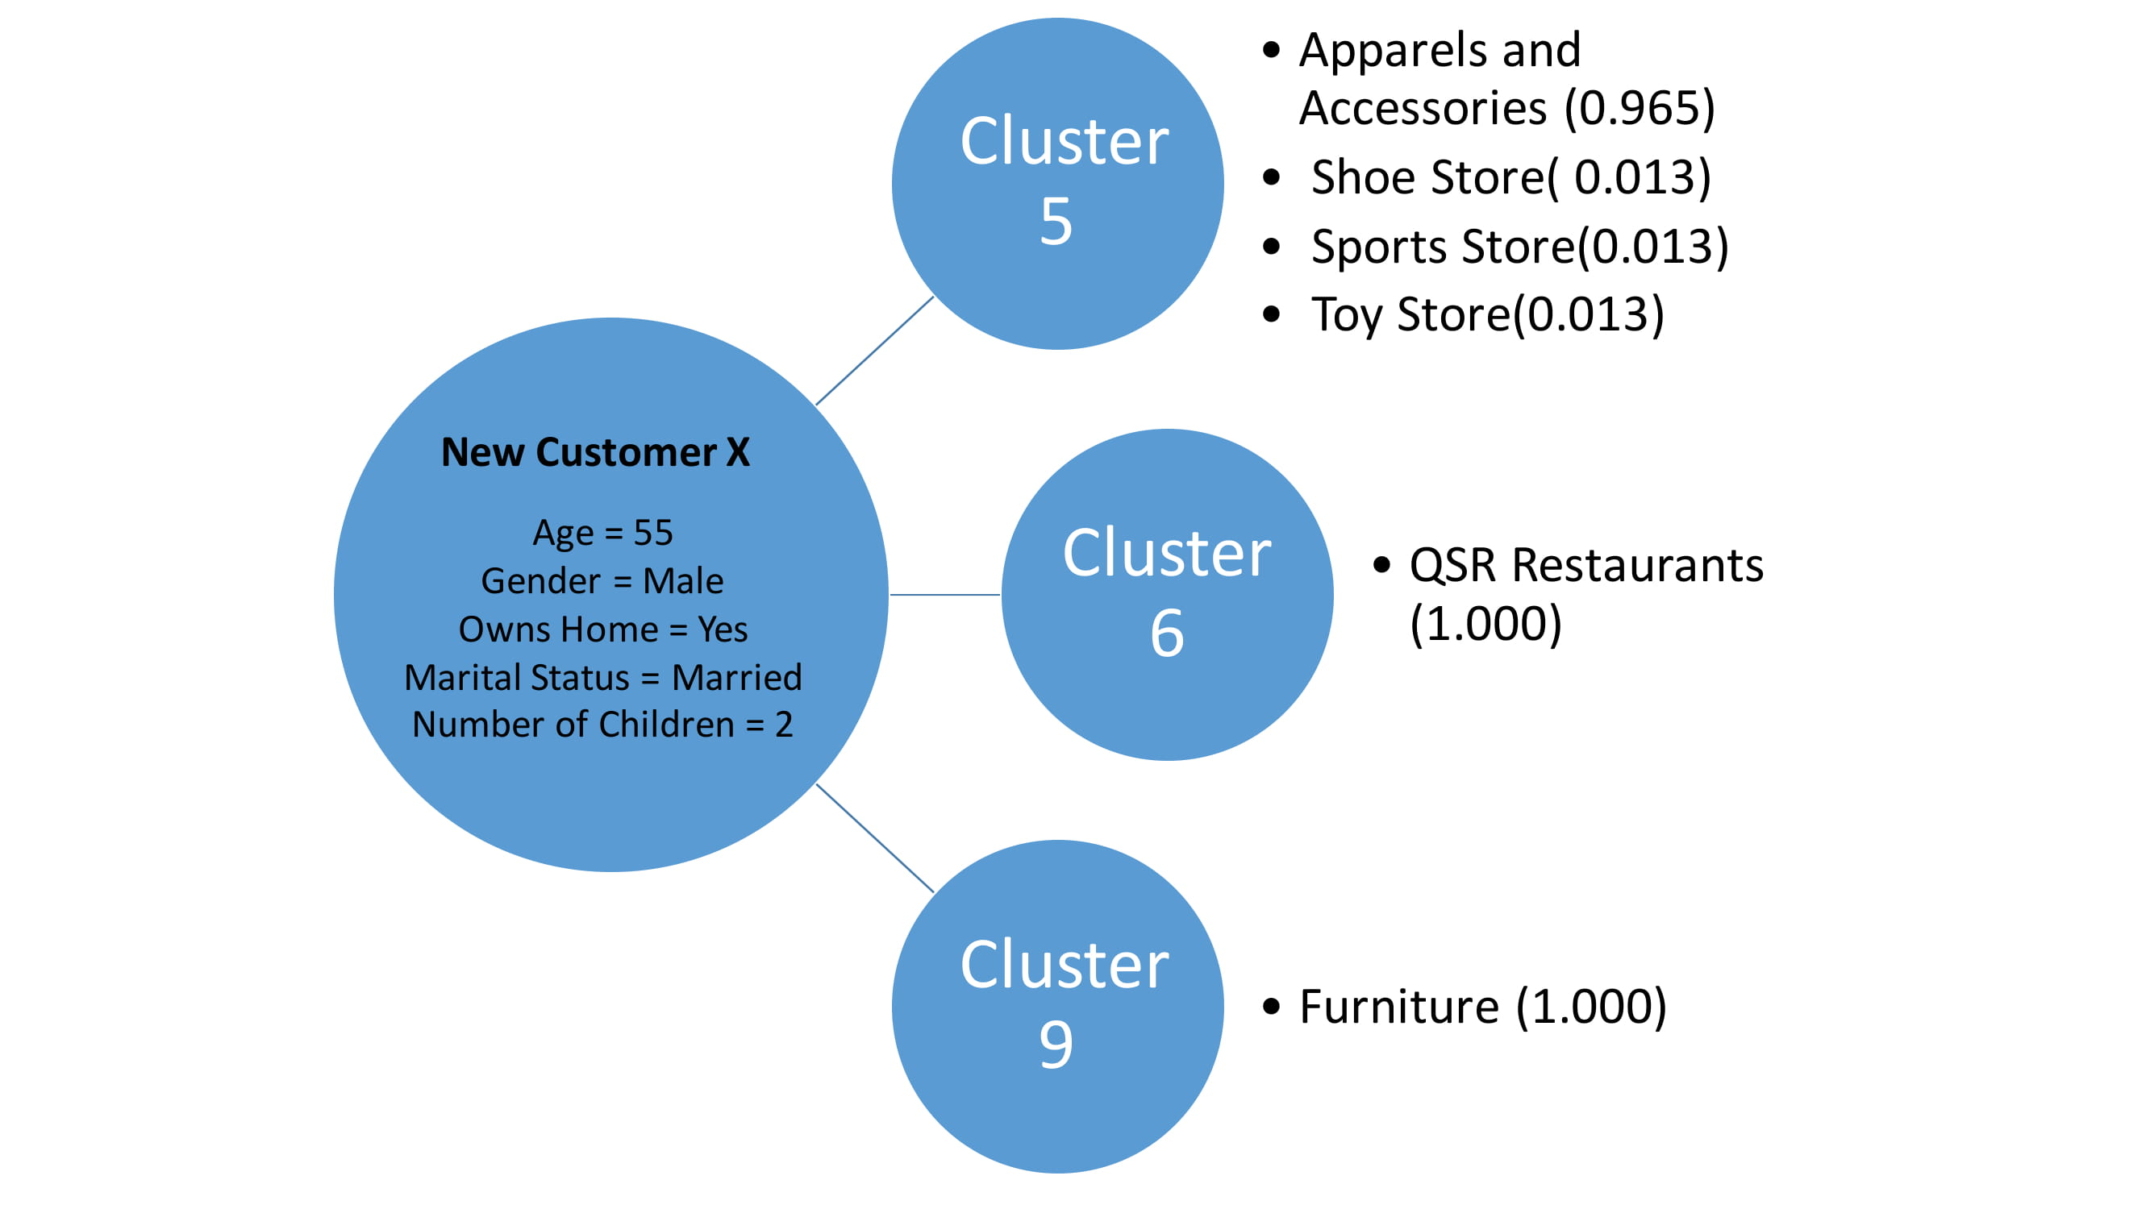

*(Note: The score assigned to each category is unique for each cluster and can be used to rank the categories to be targeted)*  
  
Thus the new customer X must be targeted personally for QSR Restaurants, Furniture Stores, Apparel and Accessories majorly.  
He/She can also be targeted for Shoe store, Sports Store, Toy Store respectively.